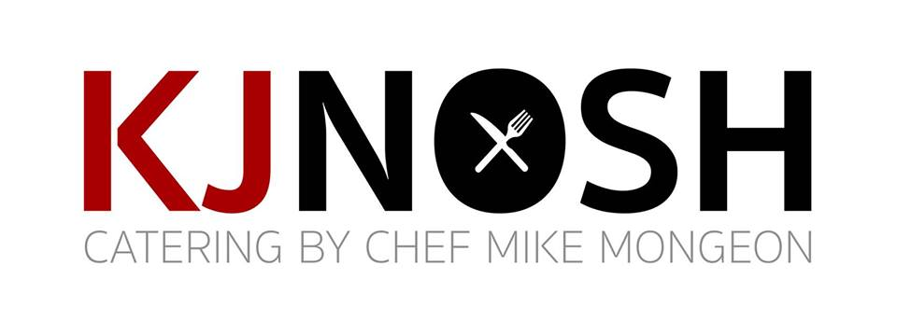
Beverage Catering | Individual Soft Drinks
Can Soda | 12oz Coca Cola Products $2 EA
Mexican Coke | 12oz Coca Cola Mexican Products $4 EA
Bottled Soda | 20oz Coca Cola Products $3 EA
Bottled Water | 16.9oz Plastic Bottle $2 EA
Simply Juices | 12oz Orange, Apple, Cranberry $3 EA
Milk | 14oz Regular or Chocolate $4 EA
PowerAde | 12oz Fruit Punch or Wild Berry $4 EA
Iced Tea | 20oz Bottle $4 EA
Lemonade | 20oz Bottle $4 EA
Monster Energy | 16oz Can $8 EA
Individual Iced Dunkin | 14oz Original $6 EA
Saratoga Still Water | 12oz Glass $5 EA
Saratoga Sparkling Water | 12oz Glass $5 EA
______________________________________________________________________________________________________________________________

Bags of Ice | 5# Bags $8 EA
______________________________________________________________________________________________________________________________

Beverage Catering | Coffee
Box Coffee | 96oz Freshly Brewed Colombian Roast $25 EA
Box Decaf | 96oz Freshly Brewed Colombian Decaf $25 EA
Box Hot Tea | 96oz Hot Tea Water & Assorted Teas $25 EA
Box Iced Coffee | 96oz Freshly Brewed Iced Colombian Roast $25 EA
Box Iced Decaf | 96oz Freshly Brewed Iced Colombian Decaf $25 EA
______________________________________________________________________________________________________________________________

Coffee Sets | Sweeteners, Creamers, Coffee Stirs, Coffee Cups & Lids $2 PP
______________________________________________________________________________________________________________________________

Beverage Catering | Group Beverages
Milk Dispenser | Whole or Skim $4 PP
Green Tea Dispenser | Green Tea w/ Fresh Lemon & Mint $3 PP
Lemonade Dispenser | Sweetened Lemonade w/ Fresh Lemon $3 PP
Iced Tea Dispenser | Sweetened Tea w/ Fresh Lemon & Mint $3 PP
Arnold Palmer Dispenser | 1/2 Sweetened Tea & 1/2 Lemonade $3 PP
Fruit Punch Dispenser | Sweetened Fruit Punch w/ Fresh Fruit $3 PP
Fresh Juice Dispenser | Orange, Cranberry, Apple $6 PP
Flavored Water Dispenser | Fresh Lemon & Cucumber $2 PP
Hot Brewed Coffee | Brewed Colombian Roast $4 PP
Hot Brewed Decaf | Brewed Colombian Decaf $4 PP
Cold Brew | Cold Brewed Colombian Roast $4 PP

Beverage Catering | Enhancements
Bloody Mary Enhancement | Lemon, Lime, Shrimp, Pepperoni, Peppers, Olives, Celery, Bacon $12 PP
Mimosa Enhancement | Berries, Kiwi, Melon, Lemon, Lime, Orange, Grapefruit, Mint, Cherry $12 PP
Hot Chocolate Enhancement | Chocolate Chips, Coconut, Nuts, Candy Canes, Marshmallow $12 PP
Ice Cream Float Enhancement | Ice Cream, Whipped Cream, Chocolate/Carmel, Soda, Mint $8 PP

